COMMISSIONED CARICATURE

Looking for a perfect, custom drawn, one-off caricature of yourself or a loved one with a Swans player of your choice? This will make a unique addition to your Swans memorabilia or make an incredible gift for any Swans fan!
Greg Smith is a sport cartoonist for Sunday Times and The West Australian Newspaper. His role call of awards includes being an eight times winner of WA media Awards best cartoon, a finalist in the best News Limited cartoonist awards from 2002-2018 as well as having his work displayed in the best political cartoons’ exhibition at Parliament House.
As a Swans diehard and the unofficial Bloods & WA Swans cartoonist Greg has agreed to produce these one-off caricatures ONLY available to Swans Supporters Australia wide.
You will receive a 40cm x 50cm original one-off colour image. Please ensure you provide 2 clear images of yourself (or the person to be included in the image) for Greg to draw. Please complete the details on the form. A recent caricature of the WA Swans Supporters Club President, Daryl Sommerville, with Lance “Buddy” Franklin is included for your viewing pleasure.
In order to secure this one of a kind Swannies masterpiece, please fill out your details below and include your preferred method of payment totalling $370 (including postage and handling) per print. Don’t forget to let us know who your favourite Swannies player is, so Greg can get to work.

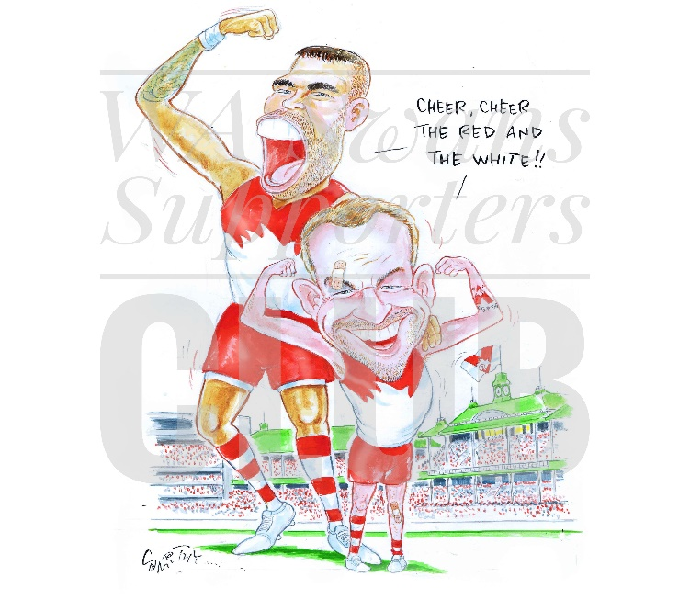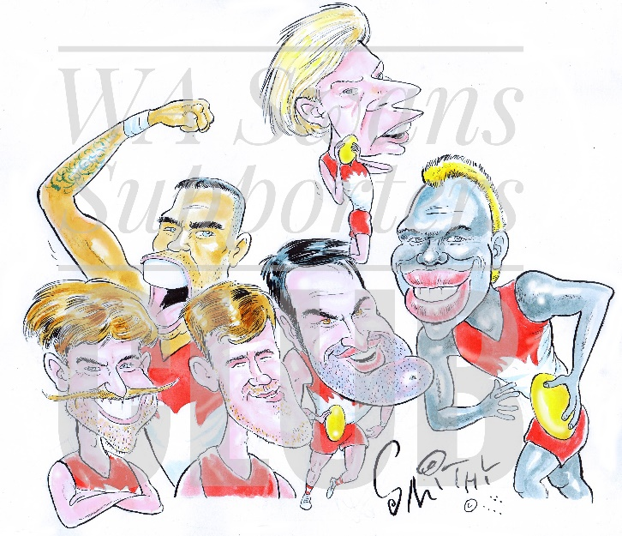
Name:
Address:
Email:
Phone:
Favourite Swans player (to be drawn with):

PLEASE SELECT A PAYMENT METHOD
Credit Card Mastercard |  | Visa
Name on Card:
Card Number:
Expiry Date: |  |  | CSV #
Signature |  |  | Date:
Electronic Bank Transfer (include a reference of your full name)
Bank: Westpac | Account Name: WA Swans
BSB: 036-074 | Account Number: 492049
Date of transfer:
Cheque made out to WA Swans (no money orders please). Enclosed is my cheque payable to WA Swans for amount of $370 (inc postage & handling)

Return completed form and your 2 photos in JPEG format to: theswan@waswans.com.au

